­­­

**Shivaji University, Kolhapur.**

**A PROJECT REPORT**

**ON**

**“E-Commerce Perfume Website”**

**Submitted To,**

**Yashwantrao Chavan School of Rural Development**

**Shivaji University, Kolhapur.**

## in the partial fulfillment of

## MCA Part-II, Sem-IV (2023-2024)

## 

**Submitted By**

**Mr. Onkar S. Yevale**

**Mr. Shreyash S. Abdagire**

**Under The Guidance of**

**Dr. Nilam Jadhav**



## 2023 – 2024

**Yashwantrao Chavan School of Rural Development**

## Shivaji University, Kolhapur

**CERTIFICATE**

This is to certify that, **Mr. Onkar Shrirang Yevale** and **Mr. Shreyash Sunil Abdagire** have satisfactorily completed the project entitled as **“E-Commerce Perfume Website”** in the partial fulfillment of MCA-II, SEM-IV during the academic year 2023-2024.

**Place:** Kolhapur

**Date:** …. /. /2024

### Internal Guide Examiner MCA Co-Ordinator

**ACKNOWLEDGEMENT**

Every project is always a scheduled, guided & coordinated team effort aimed at achieving common minimum goals. This minimum goal cannot be achieved without the guidance of guide.

It is with immense pleasure that we present our report to our project guide **Dr. Nilam Jadhav.** We find no words to describe her efforts and total confidence in our potential to see this project to completion. She has always been a source of inspiration and a tower of support boosting our moral beyond imagination. We would like to express our gratitude to our Head of the Department **Dr. Vaishali P. Bhosale I/C Director, YCSRD** for her continuing support and encouragement. We sincerely express our gratitude to our parents for their blessing for making this project successful.

Finally, we are thankful to our department and all our friends who have helped us to realize our efforts.

Thanking all of them, again.

**Place:** Kolhapur

**Date:** …. /…. /2024

## Name of Student:

**Mr. Onkar Shrirang Yevale**

**Mr. Shreyash Sunil Abdagire**

**DECLARATION**

Respected Sir/Ma'am,

We, undersigned here by declare that the project entitled **“E-Commerce Perfume Website”**. Developed under the guidance of Dr. Nilam Jadhav

The reports generated in the project work are based on the information collected by us.

**Place:** Kolhapur

**Date:** …. /…. / 2024

## Name of Student:

Mr. Onkar Shrirang Yevale

Mr. Shreyash Sunil Abdagire

**INDEX**

|  |  |  |
| --- | --- | --- |
| **SR.NO** | **TITLE** | **PAGE NO** |
| **1.** | **INTRODUCTION** |  |
| **2.** | **MANUAL SYSTEM & SYSTEM ANALYSIS** |  |
| **3.** | **OBJECTIVES** |  |
| **4.** | **DATA FLOW DIAGRAM (DFD)** |  |
| **5.** | **ENTITY RELATIONSHIP DIAGRAM (ERD)** |  |
| **6.** | **SYSTEM REQUIRMENTS** |  |
| **7.** | **FEASIBLITY STUDY** |  |
| **8.** | **OUTPUT DESIGN AND REPORTS** |  |
| **9.** | **FEATURES** |  |
| **10.** | **CONCLUSION** |  |
| **11.** | **REFERANCES** |  |

# INTRODUCTION

## INTRODUCTION:

**Introduction of the Aroma Perfume Ecommerce Website**:

In an era where personal grooming and self-expression are paramount, the fragrance industry stands as a testament to the power of scent in shaping individual identities. Perfume, with its ability to evoke emotions, memories, and desires, has become an indispensable accessory for people worldwide. The allure of fragrance transcends borders and cultures, making it a ubiquitous element of daily life.

In recognition of this cultural significance and the growing demand for convenient access to a diverse range of scents, the concept of an online perfume ecommerce website emerges. This project aims to explore the dynamics of creating a virtual platform dedicated to offering a curated selection of perfumes, catering to the varied preferences and tastes of consumers.

The essence of this project lies in the fusion of technology and tradition, leveraging the convenience of e-commerce while preserving the sensory experience that accompanies selecting and experiencing fragrances. By harnessing the power of digital platforms, this project endeavors to provide a seamless and immersive shopping experience, allowing users to explore, discover, and purchase perfumes from the comfort of their homes.

# SYSTEM ANALYSIS

System analysis for your Hospital Appointment Booking System involves a structured process of understanding, diagnosing issues, and proposing improvements for the system. It's essential to facilitate effective communication between users and developers. Here's a simplified explanation of the system analysis for your Hospital Appointment System:

**Understanding the Current System:** The first step is to through examine how your current appointment system works. This includes looking at how patients book appointments, how the staff manages these appointments, and the overall workflow.

**Identifying Problems:** As a system analyst, you need to identify any challenges or inefficiencies in the current system. This could be issues like long waiting times, appointment scheduling conflicts, or difficulty in managing patient records.

**Gathering Information:** To gather information, you may conduct interviews with hospital staff and patients. You can also use questionnaires to collect data that will help in understanding the system's strengths and weaknesses.

**Data Analysis:** Once you've collected data, you'll need to analyze it to gain insights into how the system functions and where improvements can be made. This is crucial to understand the existing system thoroughly.

**Proposing Solutions:** After identifying the problem areas, you'll work on proposing solutions to address them. These solutions might include streamlining appointment scheduling, implementing an electronic health record system, or improving patient communication.

**User Involvement:** Your proposed solutions should be presented to the hospital staff for their input and feedback. They should be involved in the decision-making process to ensure that the changes are practical and meet their needs.

**Review and Refinement:** The proposed changes are reviewed by users, and any necessary adjustments or modifications are made based on their feedback. This iterative process continues until users are satisfied with the proposed improvements.

**Feasibility Studies:** In addition to the above steps, feasibility studies are conducted to determine the cost, resource requirements, and potential benefits of implementing the proposed changes.

**Selecting the Best Solution:** Ultimately, the most suitable solution is chosen, considering user feedback, feasibility, and the expected impact on the hospital appointment system.

**Implementation:** Once a solution is selected, the implementation phase begins. This involves making the necessary changes to the system and ensuring that users are trained to use the new system effectively.

**Monitoring and Evaluation:** After the system changes are in place, continuous monitoring and evaluation are essential to ensure that the improvements are achieving the desired outcomes and that any further adjustments are made as needed.

**OBJECTIVES**

**Key Objectives :**

**Platform Development:** Design and develop a user-friendly ecommerce website tailored specifically for the sale of perfumes. This platform will prioritize intuitive navigation, visually engaging design, and robust functionality to ensure a seamless shopping experience for users.

**Product Curation and Catalogue Management:** Curate a diverse and high-quality selection of perfumes sourced from renowned brands and niche artisans. Implement effective catalogue management strategies to organize products, facilitate searchability, and enhance discoverability for users.

**Marketing and Promotion:** Develop a comprehensive marketing strategy encompassing digital advertising, social media engagement, influencer partnerships, and promotional campaigns. The goal is to increase brand awareness, drive website traffic, and ultimately boost sales and conversions.

**Customer Experience and Support:** Prioritize customer satisfaction by offering responsive customer support, hassle-free returns, and a user-friendly interface. Implement feedback mechanisms to gather insights and continuously improve the platform based on user input.

**Advanced Java Integration:** By harnessing the robust features of Advanced Java, we aim to build a dynamic and responsive website that delivers unparalleled performance and user interactivity. From seamless navigation to real-time updates, Advanced Java serves as the backbone of our platform, ensuring a smooth and engaging user experience.

**Hibernate Framework Implementation:** The Hibernate framework serves as a powerful tool for simplifying database interactions and streamlining data management processes. By integrating Hibernate into our project, we can achieve efficient object-relational mapping (ORM), enabling seamless communication between the application and the MySQL database backend.

**DFD:**

Zero Level DFD:

Admin management

User Management

Order Management

Product Management

**Level 1 DFD:**

Admin management

Product Management

Admin login

Category Management

User Management

User login

Order

Management

**Level 2 DFD:**

Admin

User Details management

Product details management

Category details Management

PP

Order details Management

**ERD:**

**Category**

**has**

**Online Shopping**

**User**

**has**

Belongs to

**ERD(Entity Relationship Diagram)**

**CartItem**

**Added to**

**Made of**

**Cart**

**Done for**

**Payment**

**does**

**buys**

**Product**

**SYSTEM REQUIREMENTS**

**SYSTEM REQUIREMENT**

* **Hardware and Software**

## Software Requirement

Operating System: Windows 11(64bit)

Web browser: Chrome, Firefox, Etc.

## Hardware Requirement:

Hard Disk : 1GB free space

RAM : 512 MB

1. **Front End**

1)JSP, Servlet

2)JAVASCRIPT

3)Bootstrap

1. **Back End**

1) Core Java

2) ORM Tool (Hibernate)

3) MYSQL (Xampp Server)

**FEASIBILITY STUDY**

**Feasibility Study:**

**Technical Feasibility:** Determine if the chosen technologies (Java, MySQL, Hibernate) are suitable for building an e-commerce website. Evaluate factors like scalability, performance, security, and compatibility.

**Market Feasibility:** Analyze the demand for e-commerce websites in the target market. Identify competitors and assess market trends to ensure there's a viable opportunity for the proposed website.

**Financial Feasibility:** Estimate the costs involved in developing, hosting, and maintaining the website. Consider factors such as development resources, hosting fees, maintenance expenses, and potential revenue streams.

**Legal and Regulatory Feasibility:** Ensure compliance with relevant laws and regulations governing e-commerce websites, such as data protection laws, consumer rights, taxation, and intellectual property rights.

**Operational Feasibility:** Assess whether the proposed e-commerce website can be effectively integrated into existing business processes and workflows. Consider factors like order processing, inventory management, payment gateways, and customer support.

**Risk Assessment:** Identify potential risks and challenges associated with building and operating an e-commerce website using Java, MySQL, and Hibernate. Develop mitigation strategies to address these risks and ensure project success.

**Non-Functional Requirement:**

Performance requirements, such as response time and scalability. Security measures to protect user data, transactions, and sensitive information. Usability considerations for intuitive user interfaces and navigation. Compatibility with different web browsers and devices.

**Timeframe:**

Development timeline, including milestones for design, development, testing, and deployment. Consideration of potential delays and dependencies.

**Stakeholder Analysis:**

Identification of stakeholders involved in the project, their roles, and responsibilities.

Analysis of stakeholder interests, concerns, and expectations.

By conducting a thorough feasibility study, you can determine whether it's viable to proceed with the development of an e-commerce website using Java, MySQL, and Hibernate, and identify any potential obstacles that need to be addressed.

**OUTPUT DESIGN AND REPORT**

**GUIs:**

**Landing Page**

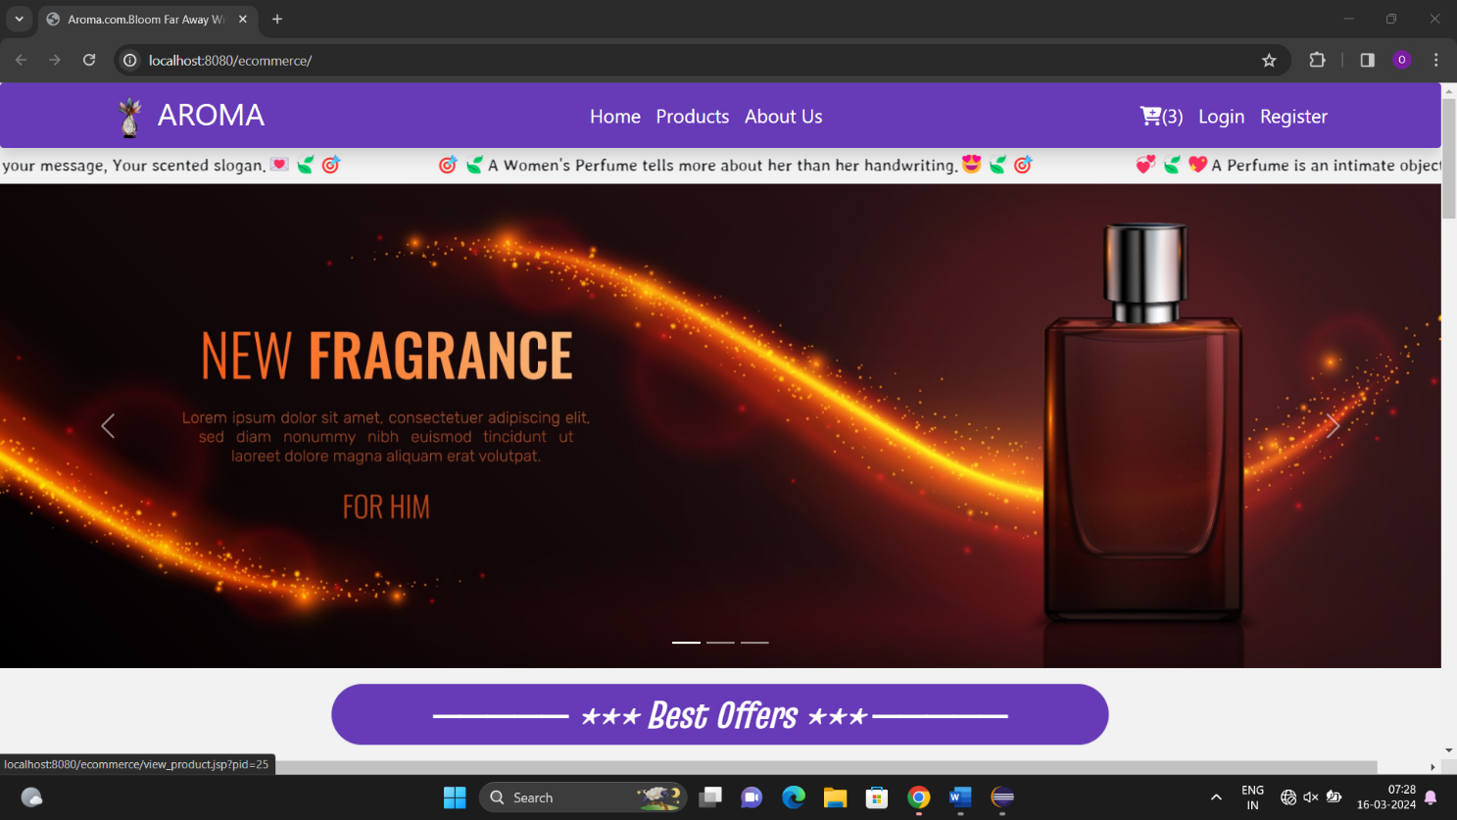

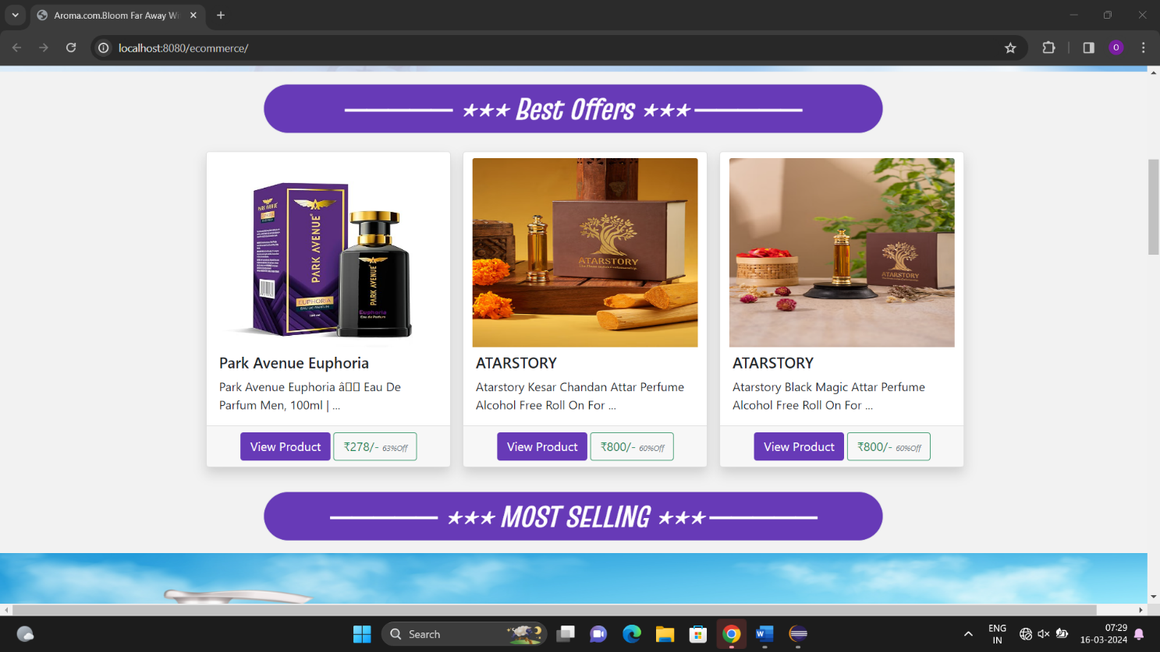

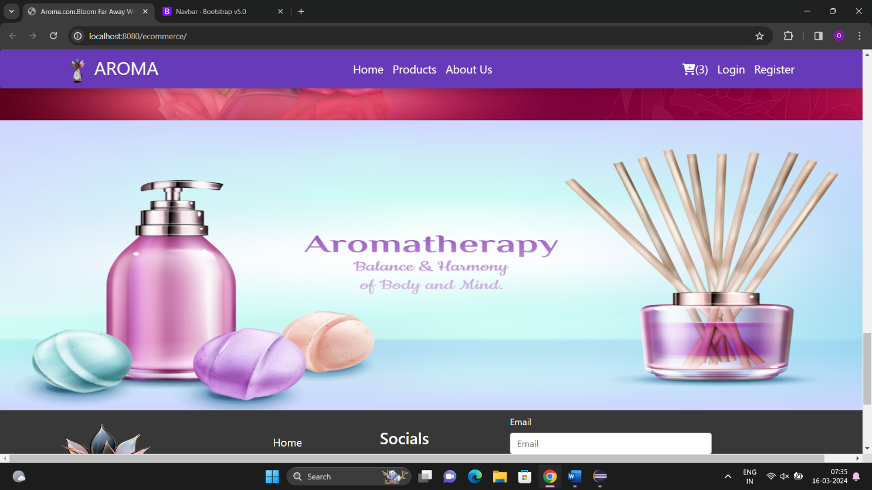

**Footer**

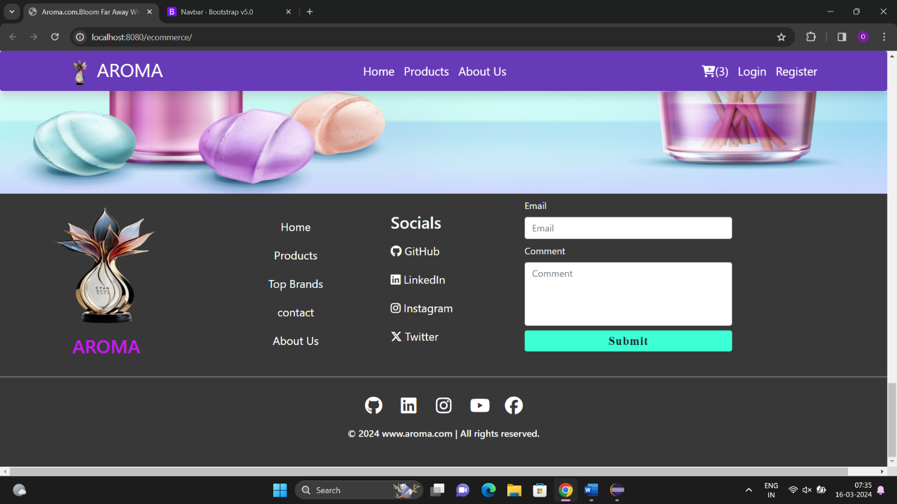

**About Us and Contact Page**

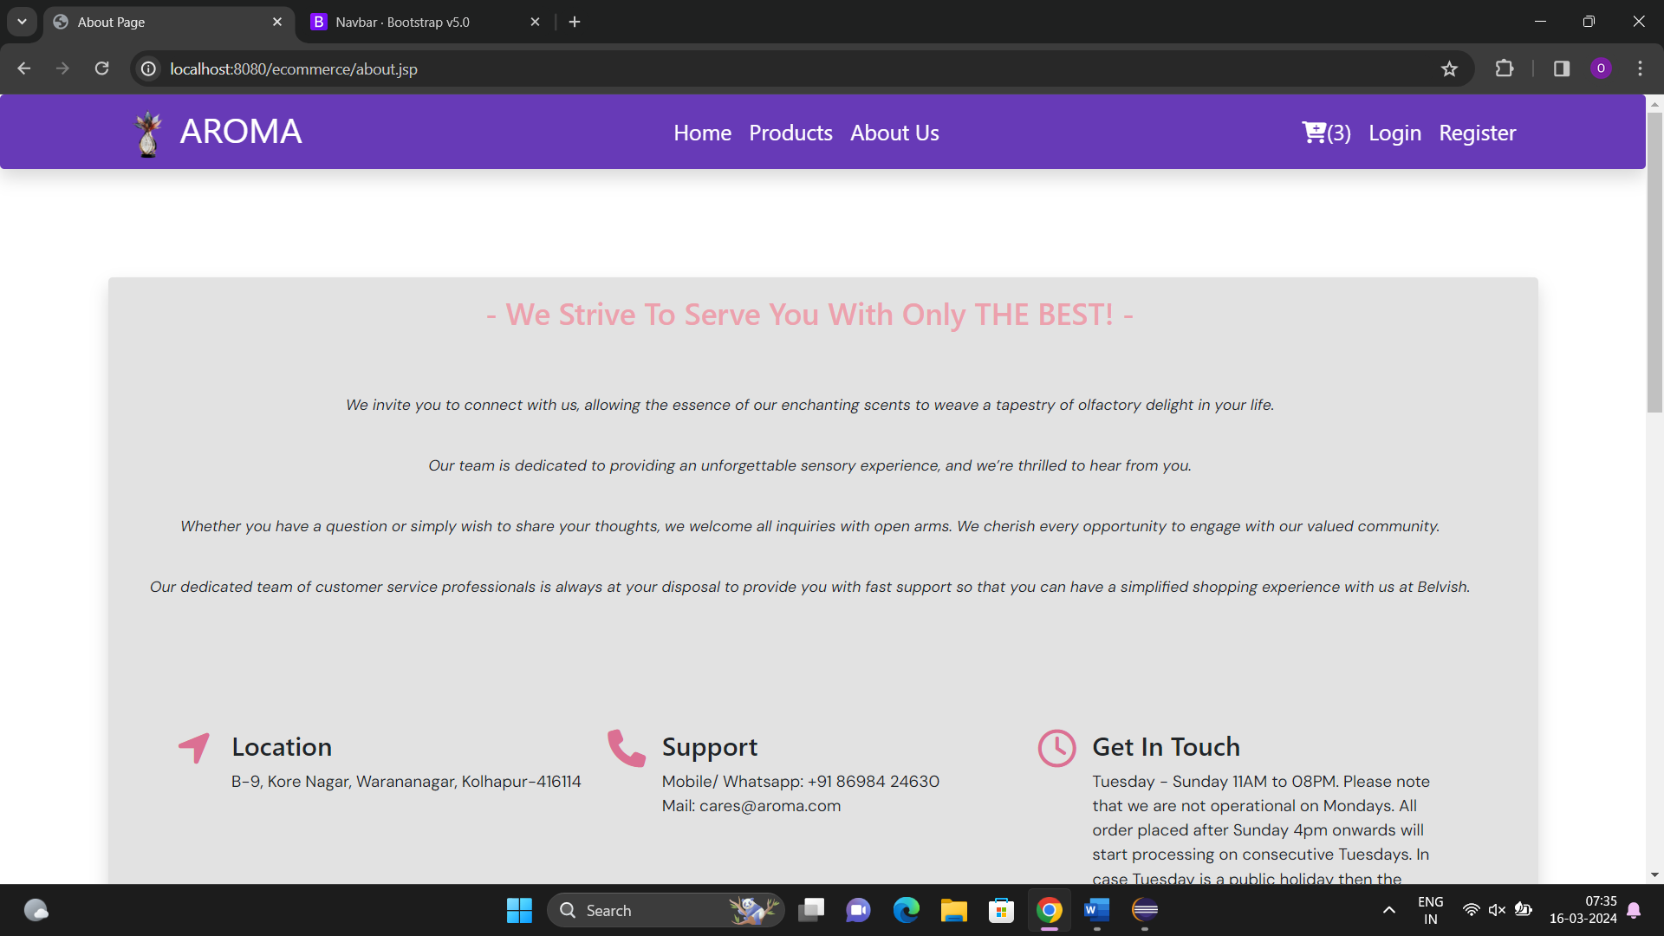

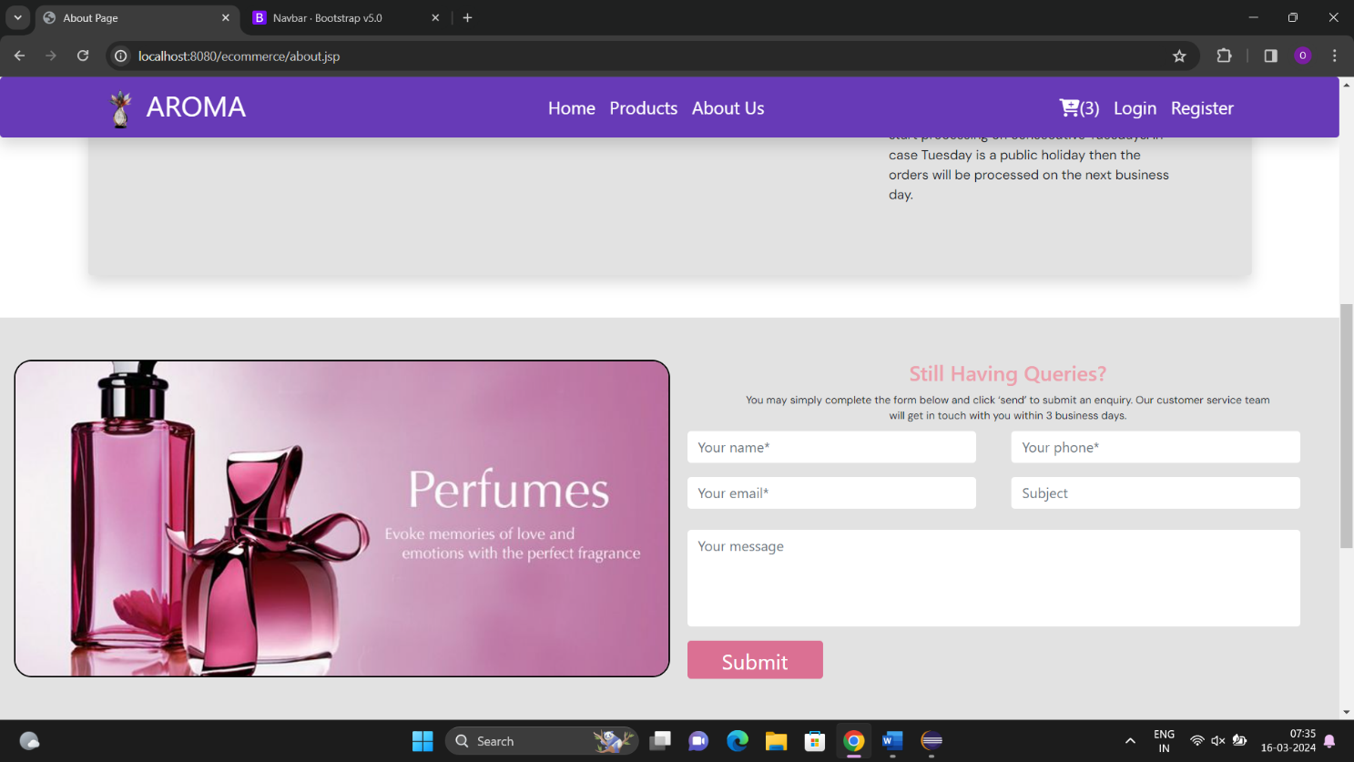

**Login Page**

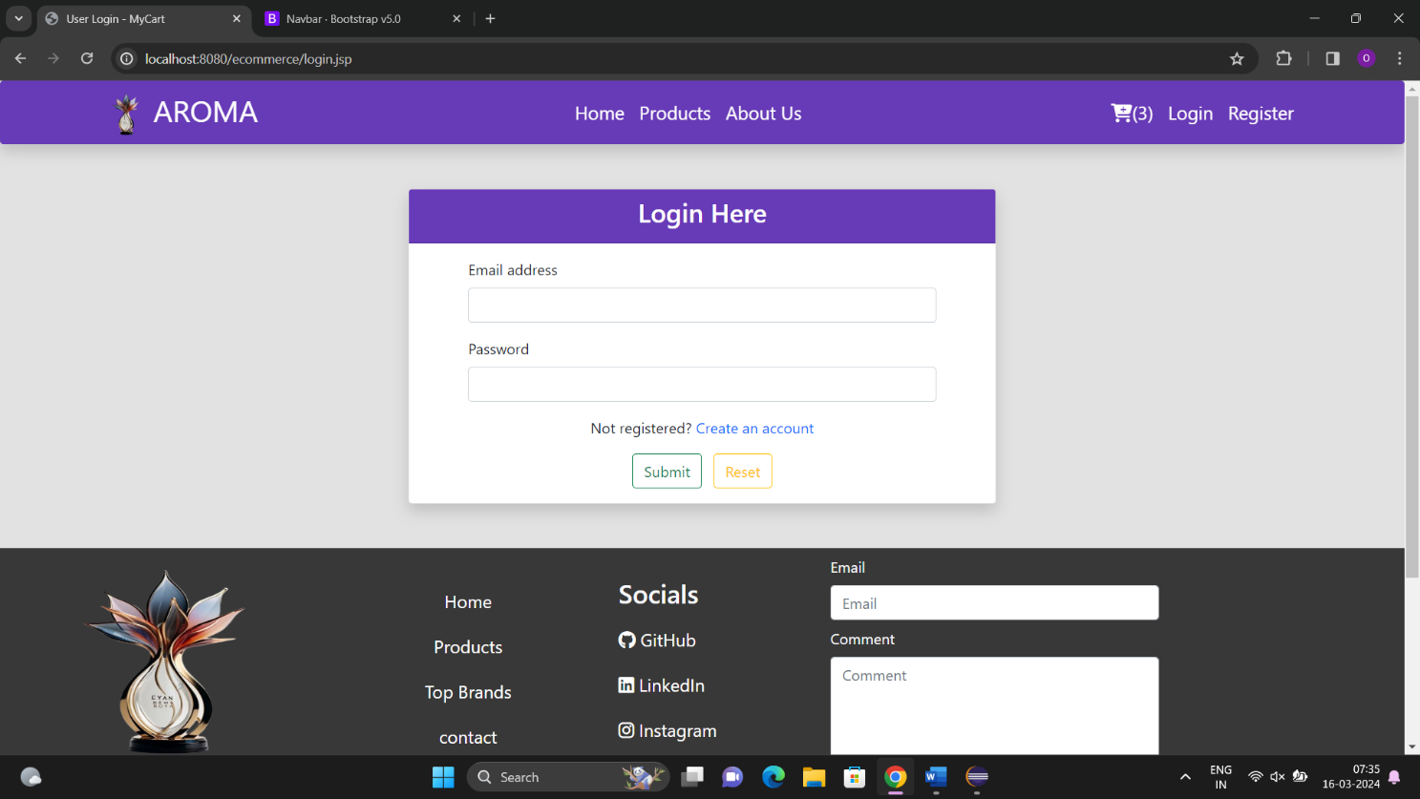

**Register Page**

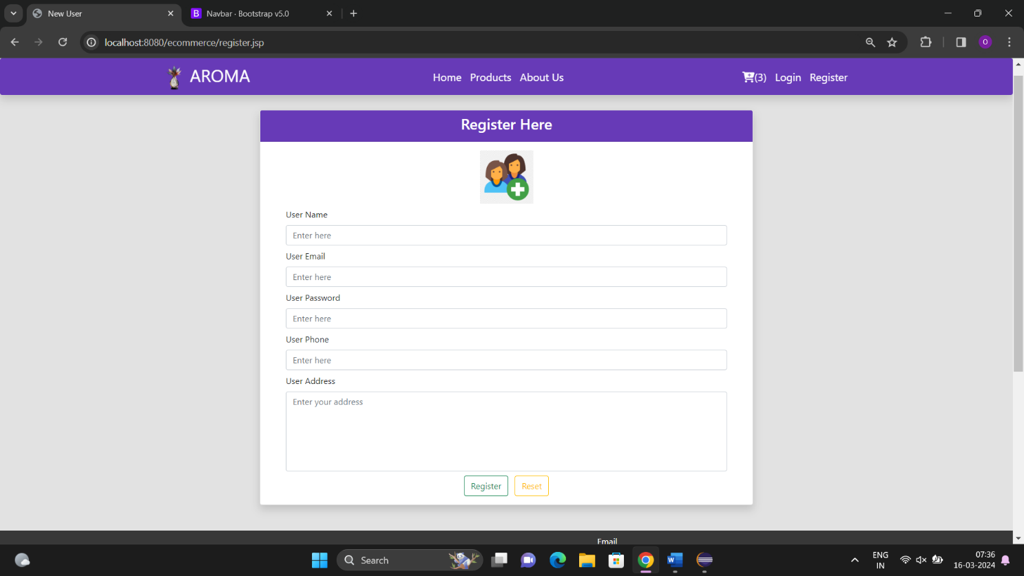

**Product Page**

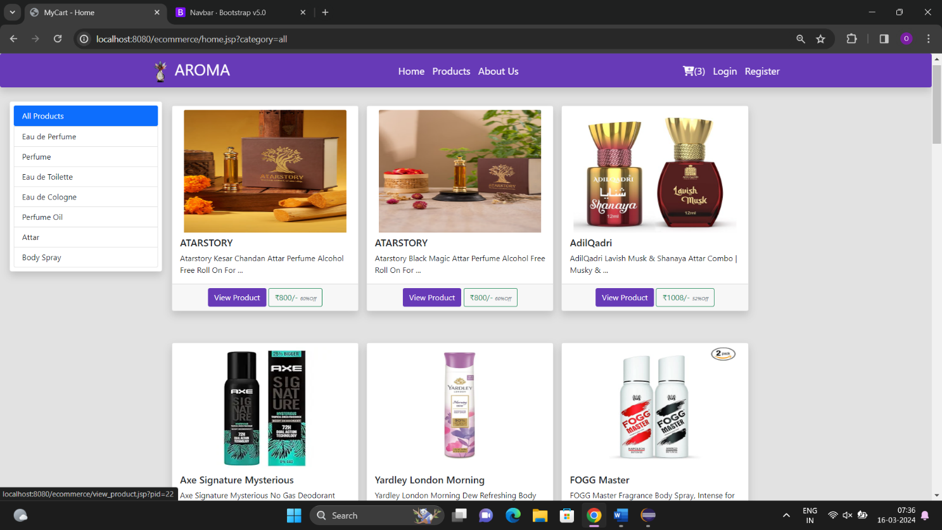

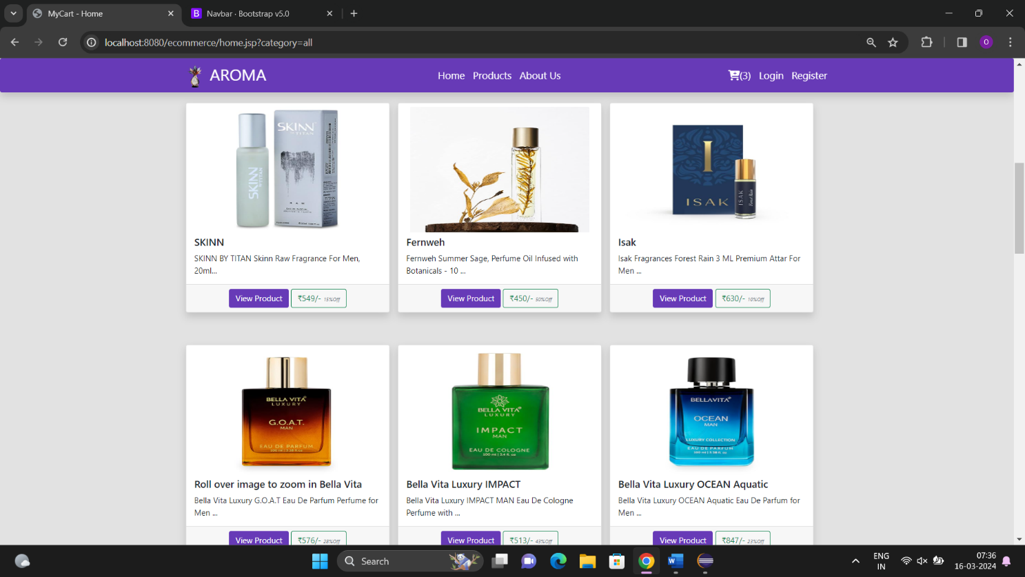

**View Product Page**

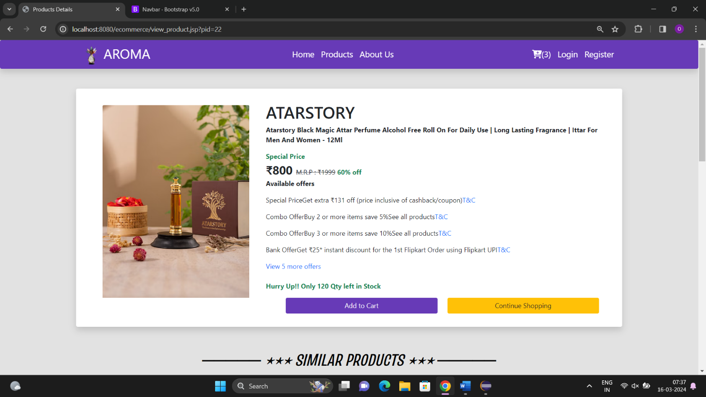

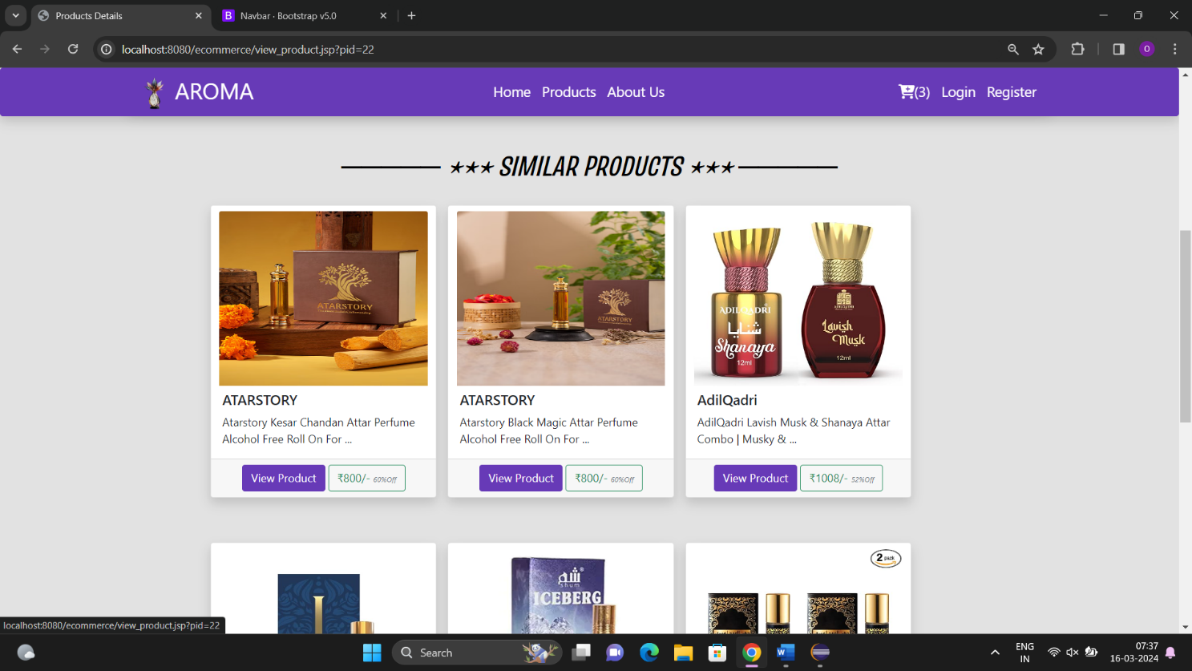

**Terms & Conditions Modal**

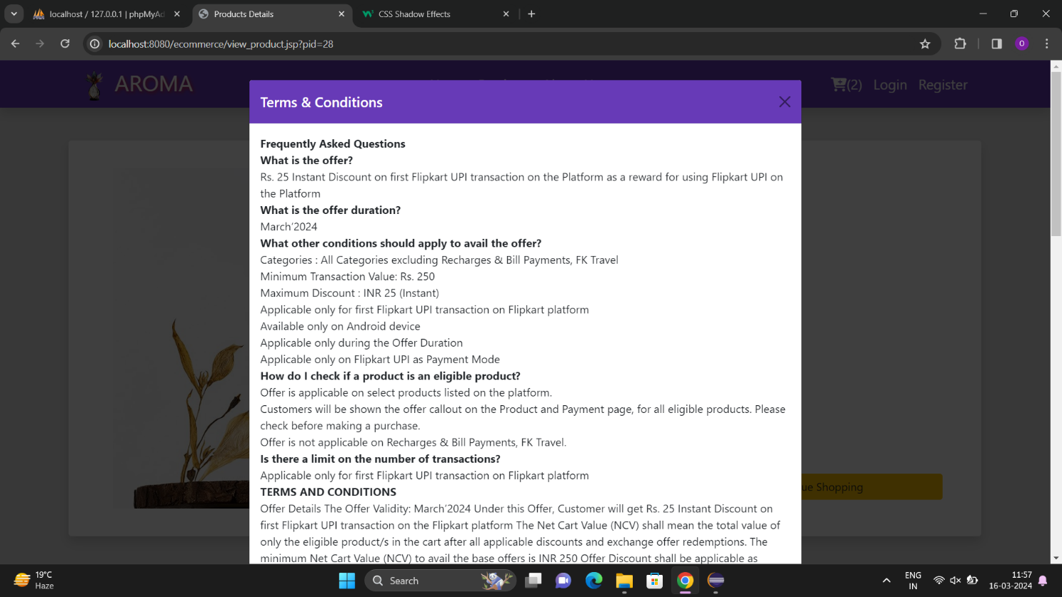

**Cart Modal**

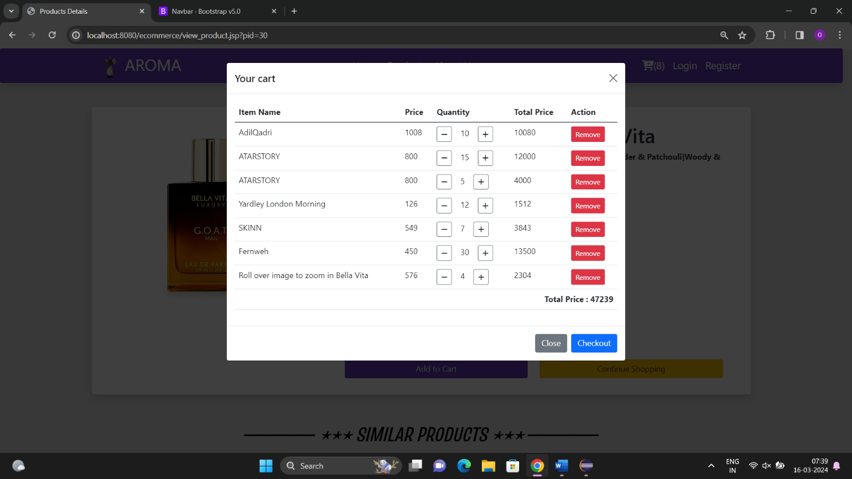

**Checkout Page**

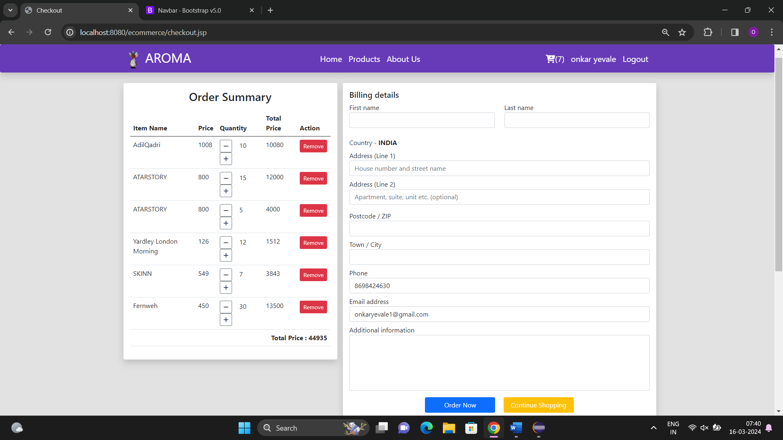

**Order Placed Page**



**Admin Dashboard Page**

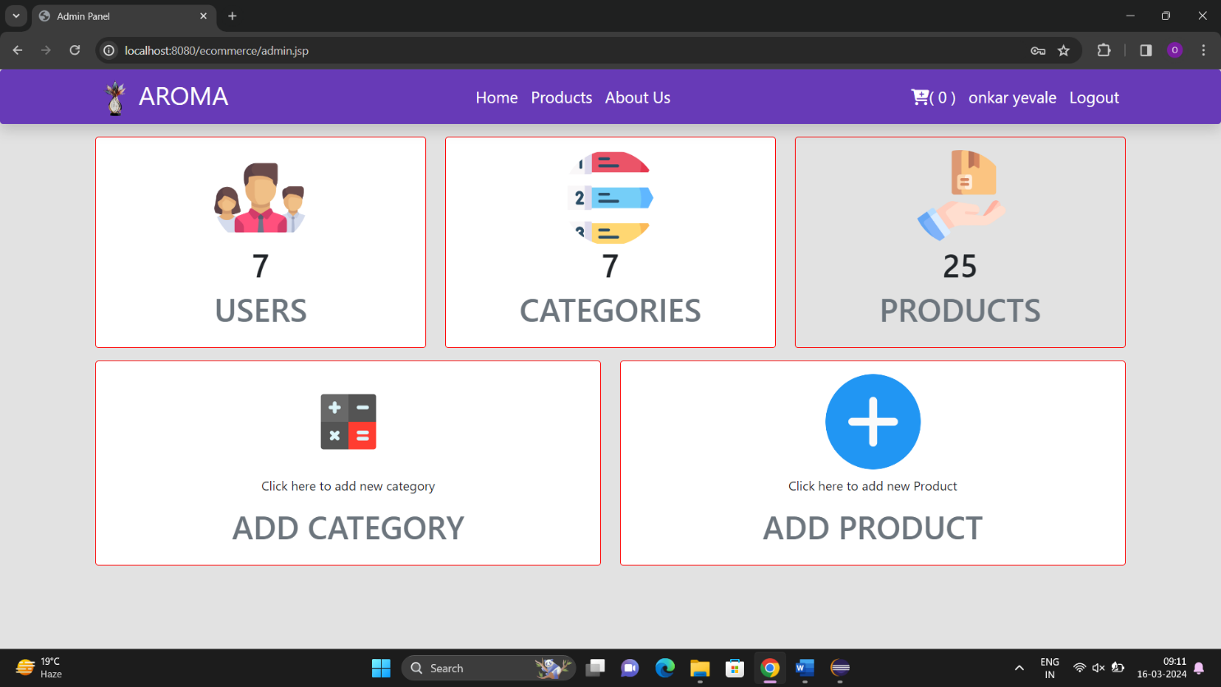

**Add Category Modal**

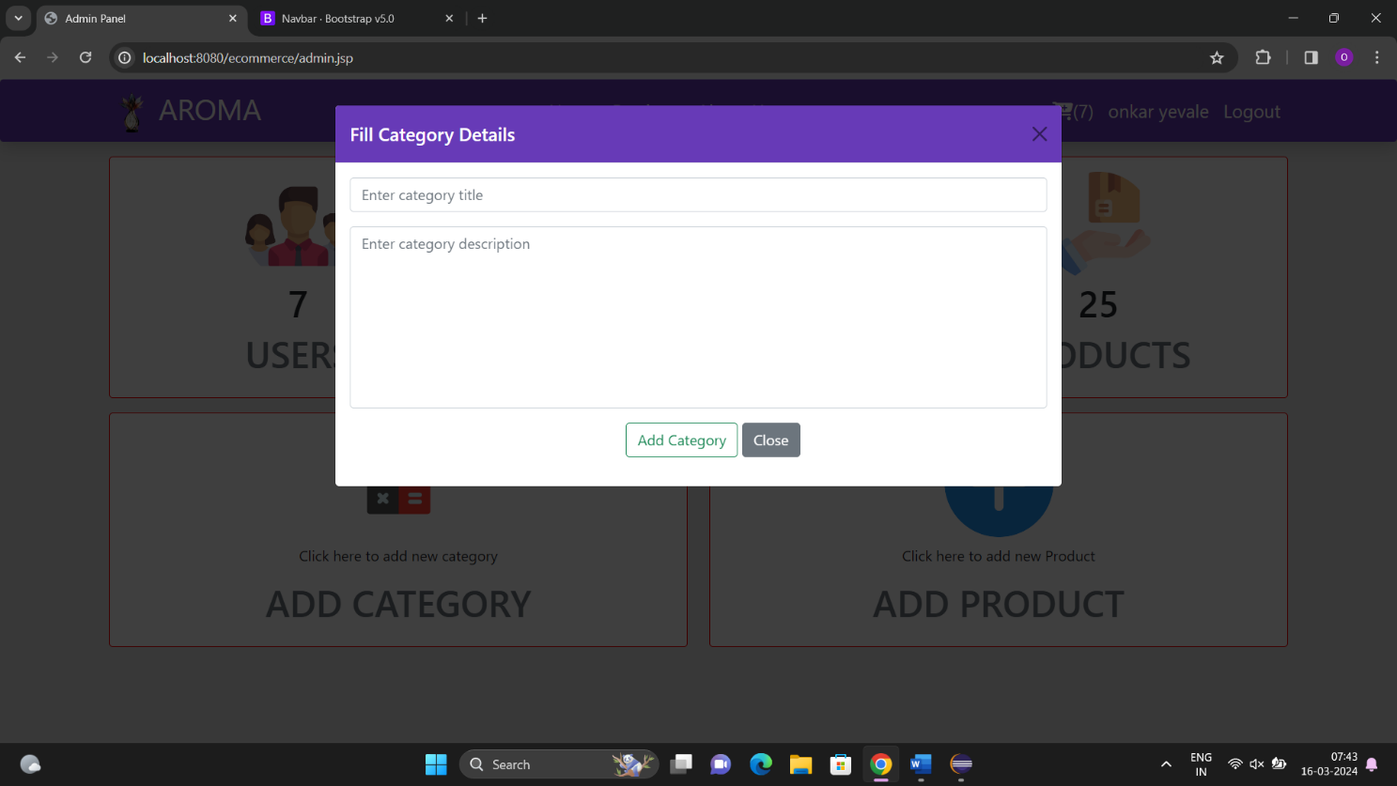

**Add Product Modal**

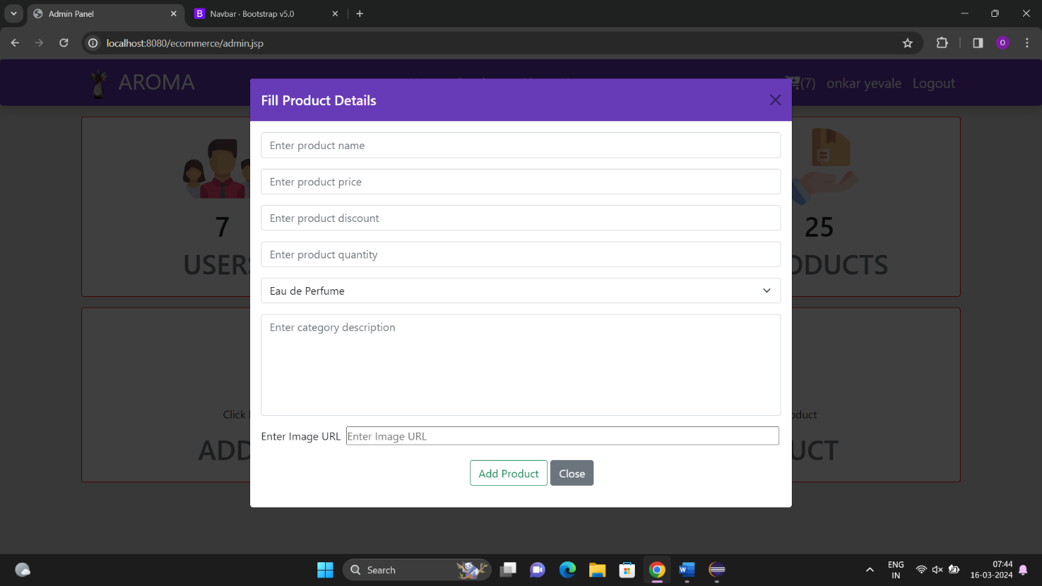

**All Products**

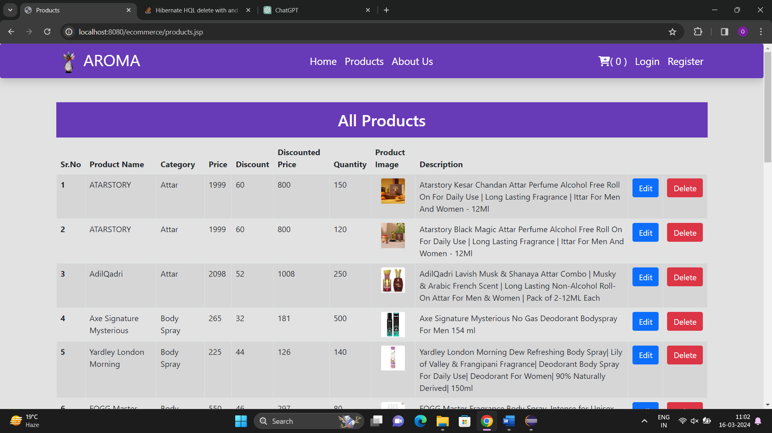

**All Users**

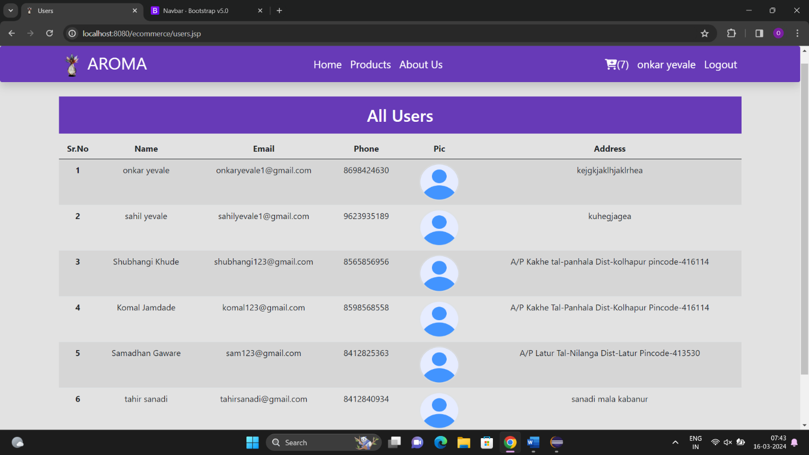

**All Category**

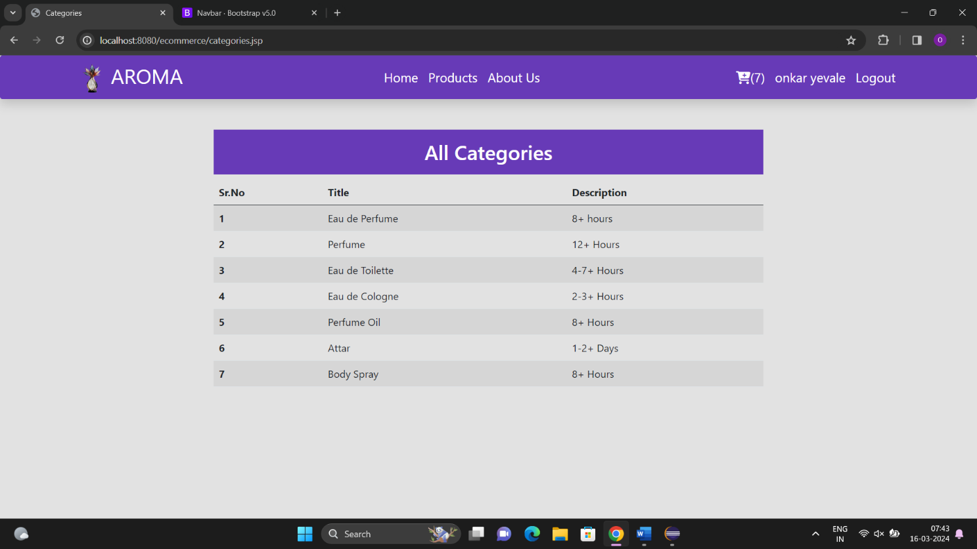

**FEATURES**

A Online Perfume E-Commerce Website offers a wide range of features that benefit both customer and owners. Some of the key features include. Here are some of the key features typically found in such a system:

* **User Registration and Authentication:**

- User registration for both admin and customer.

- Secure login/authentication mechanisms to protect user information.

* **User Profile Management:**

- User profiles with personal information, Payment history, and contact details.

- The ability for users to update their profiles and order information.

* **Secure Payments:**

- The system supports multiple payment options, ensuring secure transactions via various payment gateways.

* **Notifications and Reminders:**

- Automated email or SMS reminders for upcoming appointments.

- Notifications for any changes or cancellations in appointments.

* **Multi-Channel Order:**

- Support for online booking through a website or mobile app.

- Phone or in-person booking by shop for products without internet access.

* **Order Confirmation:**

- Automated confirmation of order to customers and service providers.

* **Access Control and Permissions:**

- Role-based access control to ensure that only authorized personnel can make changes or access sensitive data.

* **Feedback and Reviews:**

- Allow Users to leave feedback and reviews about their experiences.

* **Mobile-Friendly Interface:**

- A responsive design to ensure the system is accessible on mobile devices.

* **Security and Privacy:**

- Robust data encryption to protect users information.

* **Scalability:**

- The ability to handle a growing number of buyers, sellers and owners providers.

* **Technical Support:**

- Ongoing technical support and maintenance to address issues and updates.

A well-designed Perfume Ecommerce website should streamline the shopping perfumes, and scents process, reduce administrative workload, and enhance the user’s experience while ensuring the privacy and security of their shopping and personal information.

**CONCLUSION**

In summary, the proposed perfume ecommerce website project represents a unique opportunity to merge the timeless allure of fragrance with the convenience and accessibility of online shopping. By leveraging innovative technologies, strategic planning, and a deep understanding of consumer behavior, this project aims to create a dynamic platform that delights users and fosters a thriving online community of perfume enthusiasts. Through meticulous execution and a relentless commitment to excellence, the project endeavors to establish itself as a premier destination for fragrance aficionados worldwide.

Development of a perfume ecommerce website represents more than just a commercial venture; it symbolizes a convergence of tradition and innovation, sensory experience and digital convenience. By embarking on this project, we recognize the profound role that fragrance plays in our lives, from invoking cherished memories to expressing our unique personalities.

In This project is more than just about selling perfumes; it's about creating memorable experiences, fostering connections, and celebrating the artistry of scent. By embracing the spirit of exploration and collaboration, we look forward to building a thriving online platform that enriches the lives of our customers and contributes to the vibrant tapestry of the fragrance industry.

In conclusion, the development of a perfume website using Advanced Java, Hibernate, and MySQL represents a harmonious marriage of technological innovation and artistic expression. Through meticulous planning, rigorous development, and unwavering commitment to quality, we aim to create a platform that not only facilitates commerce but also celebrates the beauty and complexity of fragrance.

As we embark on this journey, we remain dedicated to pushing the boundaries of what is possible in the realm of e-commerce, continually striving to exceed the expectations of our customers and stakeholders. With Advanced Java, Hibernate, and MySQL as our guiding pillars, we are confident in our ability to create a truly exceptional online destination for perfume enthusiasts around the globe.

# REFERENCE

# Books:

## Complete reference of PHP & MySQL.

## Java persistence with hibernate, Second Edition.

## 

## Websites:

#### [www.stackoverflow.Com](http://www.stackoverflow.Com)

1. [www.docs.oracle.com](http://www.docs.oracle.com)
2. www.youtube.com